Established 1970
Waverley Historical Society Inc.
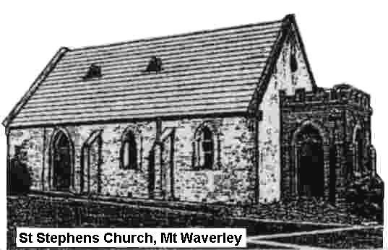
Reg No A0006377 ABN 66 135 493 929
P.O. Box 2322 Mt. Waverley VIC 3149
www.waverleyhsvic.org.au
waverleyhsvic@gmail.com
Rooms: 1st Floor Mt Waverley Library
41 Miller Cres. Mt Waverley 3149

YOUR HISTORY
Alive for future generations in Mulgrave/Waverley/Monash

Do you know your home turf? Think again. Its secrets surround you, waiting for rediscovery. Local train commuters pass the Waverley Historical Society daily, unaware that 160+ years of pioneering spirit and district development is waiting to be tapped across the road from Mt Waverley railway station. And long before rail lines and pioneering families shaped the district, this land was part of the Country cared for by the Wurundjeri and Bunurong peoples of the Kulin Nation — whose deep connection to place continues today."

OUR GOALS: To foster historical interest and knowledge, particularly of the Waverley district, acquire historical material, to research and record past and present relevant aspects of local history and assist in preserving historical landmarks in Waverley.

MEMBERSHIP provides:
- Research facilities in the WHS rooms.
- Regular newsletters,
- Affiliation with the Royal Historical Society,
- MEETINGS: Talks on selected Sunday afternoons (dates and times as per the Events Programme)
- History Walks in areas of the city on Sundays (dates and times as per the Events Programme).

****
……………….……………………………………………………………………………..……….
WHS Membership Application
Name 1 ________________________________________________________________________
Name 2 ________________________________________________________________________
Address _______________________________________________________________________
City __________________________________________ State ________ Postcode _________
Phone __________________ eMail * _______________________________________________
* Newsletters are delivered by email where possible.
Do you wish to also receive a printed copy? YES / NO
Date ______________
Annual Subscription $25 per person/household

Payment options:
Direct Deposit to WHS Account BSB 633-000 Account 161-024-278 (Please include your name in the deposit reference)
Visa/Mastercard, Cash or Cheque payable to Waverley Historical Society.

WHS 2026/v6 Office Use: Date Processed ______________

